CS 346 - Telecommunications and Networks

**LAB 7 - C# ASP.NET MVC Framework Setup**

We are headed towards the study of RESTFUL API’s. <https://www.geeksforgeeks.org/rest-api-introduction/>

In order to prepare for this we are going to setup and learn about using an MVC framework, which will help simplify the process of implementing a RESTFUL API. In this lab we will follow a tutorial to set up an ASP.NET MVC Web Application Project.

**Prerequisites**

None

[Left Blank for Formatting]

**Installing ASP.NET Packages for Visual Studio**

We will be using Visual Studio’s ASP.NET Web Development Package to create a new ASP.NET Web Application.  
  
When you Create a new Project, search for MVC

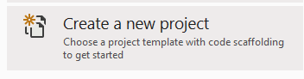



Make sure you select **ASP.NET *Core* Web Application**

If you don’t find this, then scroll down until you get to:

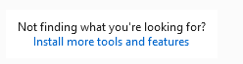

And click “Install more tools and features”  
Search for ASP.NET and install it:

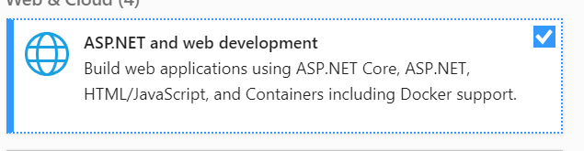

Expect a 1.55GB download

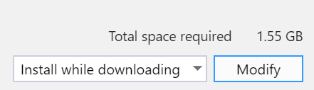

**Work through the ASP.NET MVC Tutorial**

Thoroughly read, and complete the tutorial located at:

<https://www.tutorialspoint.com/asp.net_core/asp.net_core_setup_mvc.htm>

Complete each of the following sections:

* ASP.NET Core MVC - Home
* ASP.NET Core MVC - Overview
* ASP.NET Core MVC - MVC Design Pattern
* ASP.NET Core MVC - Environment Setup ←--- **Refer to Installation Section Above if you there are problems.**
* ASP.NET Core MVC - Setup MVC
* ASP.NET Core MVC - Routing
* ASP.NET Core MVC - Action Results
* ASP.NET Core MVC - Views

**Answer These Questions**

1. The whole idea behind using the Model View Controller design pattern is that you maintain a _____________________________________.
2. List 2 of the 6 “benefits of using ASP.NET MVC”
3. What was the MVC pattern originally called in 1979?
4. What is the name of the first controller added in the tutorial?
5. The Entry point for every MVC application begins with what?

**Create A Custom Route**

Now, prove you understand how to create a new route.

Create a new route that accomplishes the following:

* **http://localhost:61465/Me/Name** should return your name and the grade you expect to receive for this assignment. (Be Generous)

Take A Screenshot of your browser displaying both of these routes. The URL as well as your name/grade should be clearly visible.

**Deliverables:**

Deliver to Canvas The following:

1. A document with the questions above answered.
2. A screenshot of your custom route running in the browser, with the URL and your name showing.

**Place the deliverables into a single document, then upload it to the LAB 9 Submission on Canvas.**